📘 Stock Valuation & Analysis Report

1. Introduction
Stock valuation is the process of finding the true value (intrinsic value) of a company’s share and comparing it with the market price.
- If Market Price < Intrinsic Value → Undervalued (Good to buy)
- If Market Price > Intrinsic Value → Overvalued (Avoid or sell)
- If Market Price ≈ Intrinsic Value → Fairly valued
Analysts use financial statements, market data, future projections, and global economic indicators.

⭐ 2. Methods Used by Experts for Valuation
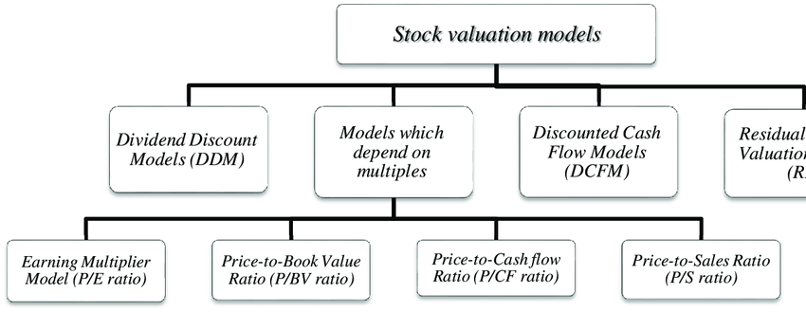
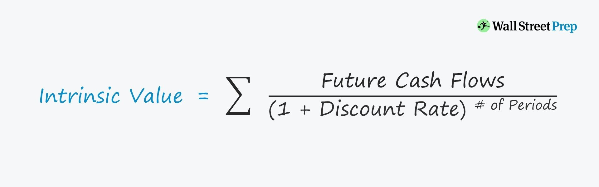

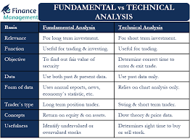

A. Fundamental Analysis
Used by investors like Warren Buffett.

1. Discounted Cash Flow (DCF)
Most accurate method.
Intrinsic Value =
Present value of all future cash flows company will generate.
Steps:
- Forecast Free Cash Flows for next 5–10 years
- Choose discount rate (WACC)
- Calculate terminal value
- Add everything → Intrinsic value
- Divide by number of shares
Used for: Large stable companies (TCS, Infosys, HDFC Bank)

B. Relative Valuation
Compare company with competitors.

1. P/E Ratio (Price to Earnings)
Formula: P/E = Market Price ÷ Earnings Per Share
- High P/E → Overvalued
- Low P/E → Undervalued
Example:
If industry P/E = 20
But stock P/E = 35 → Overvalued

2. PEG Ratio (Growth Adjusted)
Formula: PEG = P/E ÷ Growth Rate
- PEG < 1 → Undervalued
- PEG > 1 → Overvalued

3. P/B Ratio (Price to Book)
Formula: Market Price ÷ Book Value Per Share
Useful for banks, NBFCs.

4. EV/EBITDA
- Lower EV/EBITDA → Cheaper
- Higher → Expensive
Used for: IT, manufacturing, energy companies.

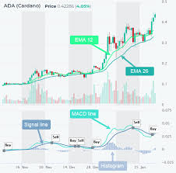
C. Technical Analysis (Price-based)
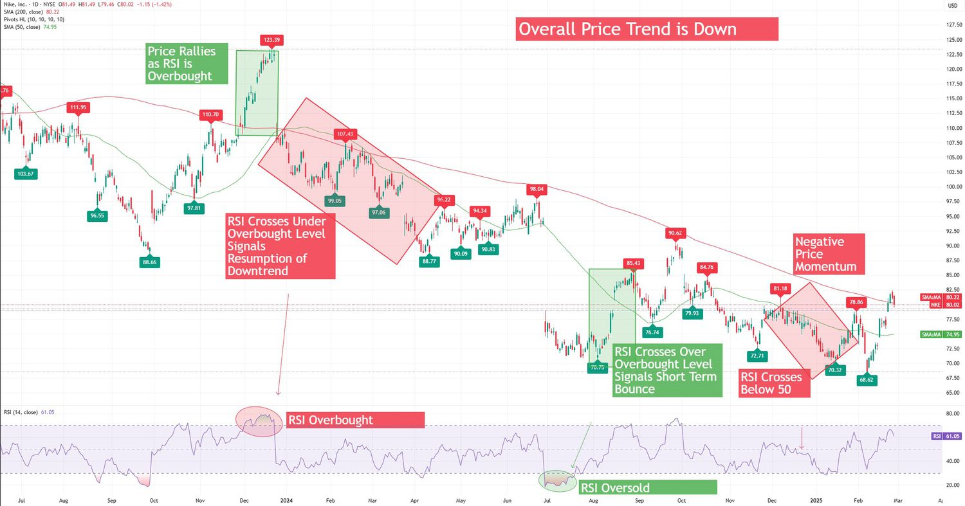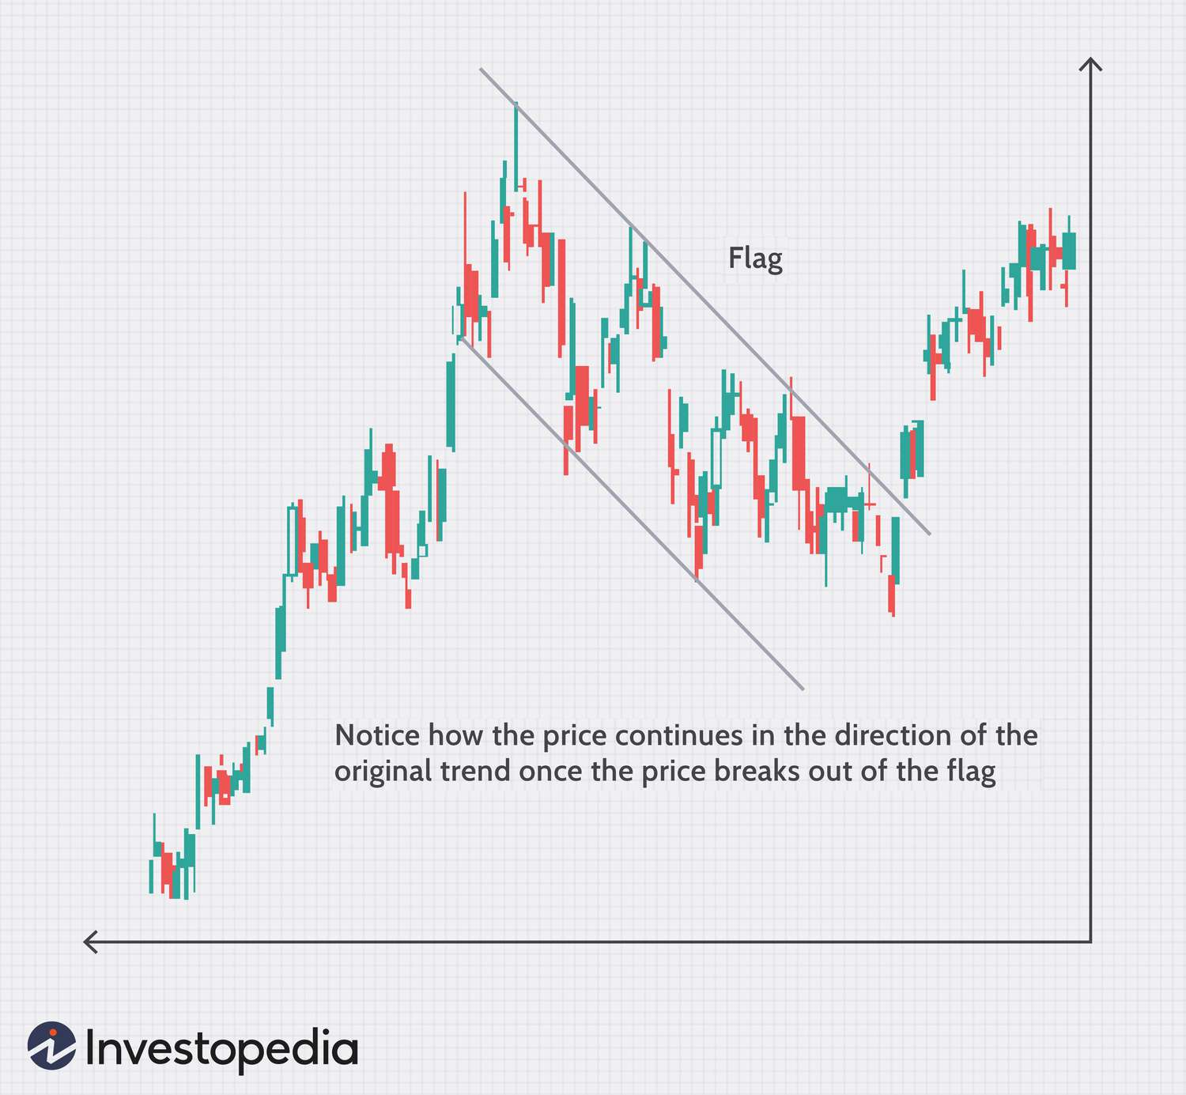
Experts also study:
- Chart patterns
- RSI (Overbought/Oversold)
- MACD
- Moving averages (50 SMA, 200 SMA)
- Volume trends

RSI Rule:
- RSI > 70 → Overbought (overvalued)
- RSI < 30 → Oversold (undervalued)

⭐ 3. Advanced Factors Experts Consider

A. Earnings Quality
- Strong EPS growth
- Stable profit margins
- High ROE (Return on Equity)
ROE > 15% = Good
ROE > 20% = Excellent

B. Debt Levels
High debt = risky
Measure: Debt-to-Equity Ratio (D/E)
- D/E < 1 = Safe
- D/E > 2 = Risky

C. Cash Flow
Free Cash Flow (FCF) must be growing every year.

D. Moat / Competitive Advantage
Examples:
- Brand (Apple, Asian Paints)
- Technology (Nvidia, TCS)
- Monopoly (IRCTC)
- Cost advantage (DMart)
Companies with moat = Higher valuation justified.

4. How Experts Decide If Stock is Overvalued or Undervalued
Here is the combined process:


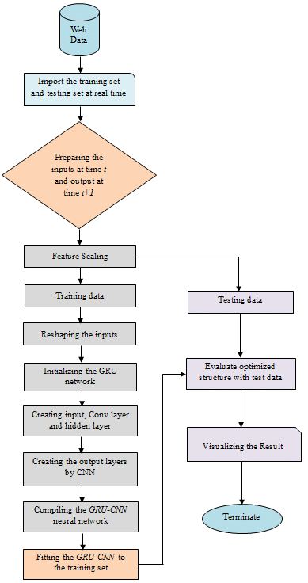

Step 1: Compare Market Price vs Intrinsic Value
Using DCF or DDM.

Step 2: Check Relative Valuations
Compare with:
- Industry P/E
- Industry P/B
- Competitor EV/EBITDA

Step 3: Analyze Growth vs Price
Use PEG ratio for accuracy.

Step 4: Check Technical Indicators
- Trend direction
- Momentum
- RSI & MACD

Step 5: Study Company Fundamentals
- Revenue growth
- Net profit growth
- Cash flow
- Debt
- ROE / ROCE

Step 6: Market Sentiment & News
- Management changes
- Quarterly results
- Interest rate changes
- Economic conditions

⭐ 5. Quick Checklist to Identify Overvalued Stock
✔ P/E much higher than industry
✔ PEG > 1.5
✔ RSI > 70
✔ Price above upper Bollinger Band
✔ Falling profit growth
✔ High debt
✔ DCF Intrinsic Value < Market Price
✔ Weak cash flow

⭐ 6. Quick Checklist for Undervalued Stock
✔ P/E lower than industry
✔ PEG < 1
✔ RSI < 30
✔ Price near 200-day moving average
✔ Strong profit growth
✔ Low debt
✔ High ROE / ROCE
✔ DCF Intrinsic Value > Market Price

⭐ 7. Example (Simple Calculation)

Company: XYZ Ltd
EPS = ₹10
Industry P/E = 20
Company P/E = 12
PEG = 0.8
ROE = 18%
D/E = 0.3

Conclusion:
Undervalued (Good buy)

⭐ 8. What You Can Do With This Knowledge
You can now build:
- Stock analysis apps
- Valuation dashboards
- AI-based price prediction system
- Screener-like website
- Backend system for financial analysis
- Automated alerts (premium selling point)

